Analysis Specifications

ID Number: | Version 1
Analysis Name: | Disposition Analysis Panel
Engine Type /  Engine Version: | SAS 9.2  Excel
Analysis Overview: | The Disposition Analysis details the number and percent of cases that correspond to each Disposition category.
Analysis Description: | The Disposition Analysis provides the user with the four analyses listed below.  Analysis 1: Disposition Events by Arm for All Subjects  Provides a table  that contains the frequency and percent of total by treatment arm for each disposition event broken down by category and sub-category as submitted by the sponsor.  Analysis 2: Disposition Events by Arm for Exposed Subjects  For subjects that had at least one drug exposure provides a table  that contains the frequency and percent of total by treatment arm for each disposition event broken down by category and sub-category as submitted by the sponsor.  Analysis 3: Time to Disposition Event by Arm for All Subjects  For each disposition event in a chosen category and subcategory, provides a graph showing the cumulative proportion of subject disposition events over time, using the study day.  Analysis 4: Time to Disposition Event by Arm for Exposed Subjects  For each disposition event in a chosen category and subcategory, provides a graph showing the cumulative proportion of exposed subject disposition events over time, using the study day.
Precondition(s): | The Disposition Analysis has the following preconditions:  - A Demographics (DM) dataset has to exist according to CDISC format specifications.  - USUBJID is required  - ACTARM or ARM is required; ACTARM is used in preference to ARM  - RFSTDTC is required if DS.DSSTDY is not present  - ARMCD is used if available  - A Disposition (DS) dataset has to exist according to CDISC format specifications.  - USUBJID and DSDECOD are required  - DSSTDY or DSSTDTC are required  - DSCAT and DSSCAT are optional  - An Exposure (EX) dataset has to exist according to CDISC format specifications.  - USUBJID is required
Study Design: | The Disposition Analysis Panel will not work with cross over studies unless the data is presented in a parallel study data structure.
Panel Options: | The following is a list of macro variables that the user is required (subc and subcatc are optional) to enter a value for. The values entered will be used to subset Disposition Events used in Analysis 3 and Analysis 4:
  Macro Variable | Possible Values | Default
  catc | Any disposition category variable in the DS dataset. Possible values: DSCAT, EPOCH, … | DSCAT
  catdis | A record value within macro variable ‘catc’. Possible values: Disposition Event, Protocol Milestone, Other Event | ‘DISPOSITION EVENT’
  subc  <optional> | Any disposition category variable in the DS dataset. Possible values: <null>, DSSCAT, EPOCH, … | <null>
  subcatdis <optional> | A record value within macro variable ‘subc’. Possible values: <null>, ‘End of Treatment’, ‘Treatment’, ‘Follow Up’, … | <null>
Input(s): | The Disposition Analysis uses the following data and variables:  - DM –  - DM.ACTARM  - DM.ARM  - DM.ARMCD  - DM.RFSTDTC  - DM.USUBJID  - DS –  - DS.DSDECOD  - DS.USUBJID  - DS.DSSTDTC  - DS.DSSTY  - DS.DSCAT  - DS.DSSCAT  - EX –  - EX.USUBJID
Input from: | The datasets required to perform the Disposition Analysis are passed to it by Script Launcher
Process Flow: | The process flow diagram below provides the User a graphical representation of the Disposition Analysis steps.  DM  DS  Use DM Dataset to determine the arm variable to get treatment group for each subject  Analysis 1: Disposition Events by Arm for All Subjects  DSCAT  DSSCAT  DSDECOD  USUBJID  ACTARM  Subjects’ Treatment Groups  Number and Percent by Disposition Events  Output Chart to Excel  DM  DS  Use DM Dataset to determine the Arm variable to get treatment group for each subject  Analysis 2: Disposition Events by Arm for Exposed Subjects  DSCAT  DSSCAT  DSDECOD  USUBJID  ACTARM  Subjects’ Treatment Groups  Number and Percent by Disposition Events  Output Chart to Excel  EX  DM  DS  Use DM Dataset to determine the arm variable to get treatment group for each subject  Analysis 3: Time to Disposition Event by Arm for All Subjects  DSSTDY or RFSTDTC/ DSSTDTC  DSDECOD  (Subset to a chosen category and subcategory)  USUBJID  ACTARM  Subjects’ Treatment Groups  Disposition Events by Days in the Study  Output Chart to Excel  Use DM Dataset to determine the arm variable to get treatment group for each subject  Analysis 4: Time to Disposition Event by Arm for Exposed Subjects  DM  DS  DSSTDY or RFSTDTC/ DSSTDTC  DSDECOD  (Subset to a chosen category and subcategory)  ACTARM  Subjects’ Treatment Groups  Disposition Events by Days in the Study  Output Chart to Excel  USUBJID  EX
Requirements: | The Disposition Analysis will perform and execute the following steps in the prescribed order:  Data Pre-processing:  - Identify the Disposition, Exposure, and Demographic Datasets.  - Determine whether the Disposition, Exposure, and Demographics Datasets are in the prescribed CDISC SDTM format and whether the variables within the Dataset comply with CDISC SDTM standards.  - Exposure Dataset EX  - Demographics Dataset DM  - Disposition Dataset DS  - Determine whether the needed Exposure variables are present within the Exposure dataset. These necessary variables include:  - USUBJID  - Determine whether the needed Demographic variables are present within the Demographics Dataset.  - If ARMCD is equal “SCRNFAIL” or “NOTASSGN” then delete  - ACTARM or ARM; ACTARM used in preference to ARM  - ARMCD is used if available  - RFSTDTC (if DSSTDY not present)  - USUBJID  - Determine whether the needed Disposition variables are present within the Disposition Dataset.  - DSDECOD  - USUBJID  - DSSTDTC (if DSSTDY not present)  - DSSTDY  - DSCAT (not required)  - If not present, create it and set it to ‘Missing’  - DSSCAT (not required)  - If not present, create it and set it to ‘Missing’  - If all required variables are present then proceed.  - Merge the Disposition and Demographics Datasets by USUBJID and keep observations that are in both.  Analysis 1: Disposition Events by Arm for All Subjects  - Provides a table  that contains the frequency and percent of total by treatment arm for each Disposition event broken down by category and sub-category as submitted by the sponsor.  - Excepting disposition events whose category (DSCAT) is ‘Protocol Milestone’ or whose standardized disposition term is ‘Informed Consent Obtained’ or ‘Randomized’ using case-insensitive comparisons, reduce the dataset to one row per subject (USUBJID), disposition category (DSCAT), and disposition event subcategory (DSSCAT) using the DSSTDY to determine last disposition event per subcategory, or the difference between DSSTDTC and RFSTDTC if DSSTDY is not available. If more than one event has the same study day, keep death disposition events.  - Find frequency counts of each disposition event by arm  - Determine denominator  - Find the number of subjects per arm in the merged DS/DM dataset with ‘RANDOM’ in DSDECOD  - If no one has a DSDECOD value containing ‘RANDOM’, use the count of unique subjects by arm in the merged dataset as the denominator for percentage calculations.  - Calculate percentages using the frequency count from 1.2 as the numerator and the denominator from 1.3  - The outputs of Analysis 1 will be exported to Excel and defined as  - A table listing DSCAT, DSSCAT, DSDECOD giving frequency (count) and percentage of subjects by arm  Analysis 2: Disposition Events by Arm for Exposed Subjects  - Provides a table  that contains the frequency and percent of total by treatment arm for each disposition event experienced by subjects with at least one exposure broken down by category and sub-category as submitted by the sponsor.  - Using the exposure domain dataset (EX), look up whether each subject in the merged DS/DM dataset has at least one exposure event in EX using USUBJID. Keep those that do.  - Excepting disposition events whose category (DSCAT) is ‘Protocol Milestone’ or whose standardized disposition term is ‘Informed Consent Obtained’ or ‘Randomized’ using case-insensitive comparisons, reduce the dataset to one row per subject (USUBJID), disposition category (DSCAT), and disposition event subcategory (DSSCAT) using the DSSTDY to determine last disposition event per subcategory, or the difference between DSSTDTC and RFSTDTC if DSSTDY is not available. If more than one event has the same study day, keep death disposition events.  - Find frequency counts of each disposition event by arm  - Determine denominator  - Find the number of subjects per arm in the merged DS/DM/EX dataset with ‘RANDOM’ in DSDECOD  - If no one has a DSDECOD value containing ‘RANDOM’, use the count of unique subjects by arm in the merged dataset as the denominator for percentage calculations.  - Calculate percentages using the frequency count from 1.2 as the numerator and the denominator from 1.3  - The outputs of Analysis 1 will be exported in Excel/Word and defined as  - A table listing DSCAT, DSSCAT, DSDECOD giving frequency (count) and percentage of subjects by arm  Analysis 3: Time to Disposition Event by Arm for All Subjects  - For each disposition event in a chosen category and subcategory, provide a graph showing the cumulative proportion of subject disposition events over time, using the study day.  - Subset the DS domain to a chosen category and subcategory of disposition events using the macro variables CATC, CATCDIS, SUBC, SUBCATDIS. Subcategory is not required.  - Calculate the study day that each disposition event chosen in 1.1 occurs.  - If DSSTDY exists use as study day  - If DSSTDY doesn’t exist calculate study day as the difference between RFSTDTC and DSSTDTC  - Determine the number of Disposition Events occurring each study day by arm for the numerators in the cumulative proportion calculations  - Summarize by arm, study day, and DSDECOD  - Determine the number of each disposition event remaining on each study day by treatment for the denominator in the cumulative proportion calculations  - Summarize by arm and study day  - Fill in any missing study days with the same number as the previous day  - Calculate cumulative proportion  - Merge datasets created in steps 1.2 and 1.3  - Divide the numerators by the denominators  - Keep 12 most prevalent Disposition Events for final output  - If less than 12 Disposition Events occur, keep all of them  - The outputs of Analysis 3 will be exported to Excel and defined as  - By Disposition event a line graph  - Each Arm is a series  - Cumulative proportion as the Y-axis  - Study Day as the X-axis  Analysis 4: Time to Disposition Event by Arm for Exposed Subjects  - For each disposition event in a chosen category and subcategory, provide a graph showing the cumulative proportion of subject disposition events over time, using the study day.  - Look up whether the subjects in the merged DS/DM dataset have at least one exposure event in the EX dataset using USUBJID and keep those that do.  - Subset the DS domain to a chosen category and subcategory of disposition events using the macro variables CATC, CATCDIS, SUBC, SUBCATDIS. Subcategory is not required.  - Calculate the study day that each Disposition event occurs.  - If DSSTDY exists use as study day  - If DSSTDY doesn’t exist calculate study day as the difference between RFSTDTC and DSSTDTC  - Determine the number of Disposition Events occurring each study day by arm for the numerators in the cumulative proportion calculations  - Summarize by arm, study day, and DSDECOD  - Determine the number of each disposition event remaining on each study day by treatment for the denominator in the cumulative proportion calculations  - Summarize by arm and study day  - Fill in any missing study days with the same number as the previous day  - Calculate cumulative proportion  - Merge datasets created in steps 1.3 and 1.4  - Divide the numerators by the denominators  - Keep 12 most prevalent Disposition events for final output  - If less than 12 Disposition events occur, keep all of them  - The outputs of Analysis 4 will be exported in Excel/Word and defined as  - By Disposition event a line graph  - Each Arm is a series  - Cumulative proportion as the Y-axis  - Study Day as the X-axis
Screenshots: | Analysis 1: Disposition Events by Arm for All Subjects  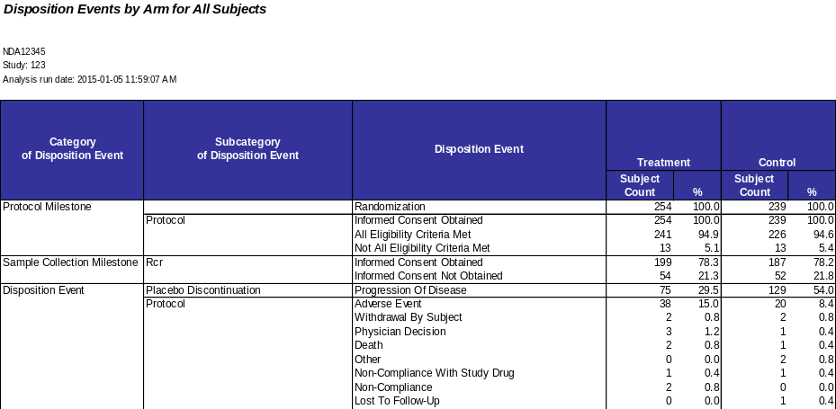  Analysis 2: Disposition Events by Arm for Exposed Subjects  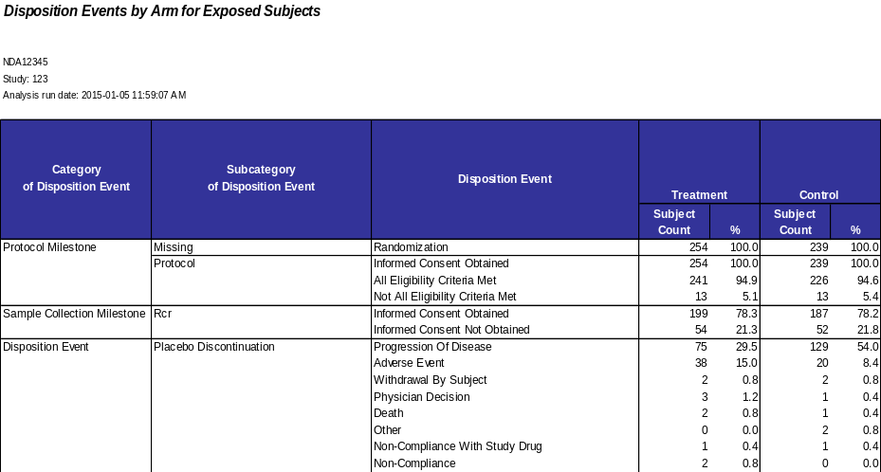  Analysis 3: Time to Disposition Event by Arm for All Subjects  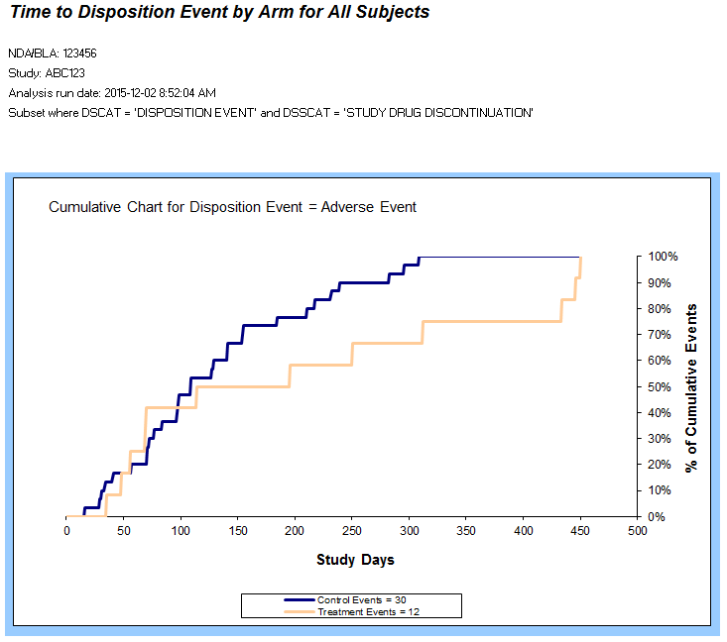  Analysis 4: Time to Disposition Event by Arm for Exposed Subjects  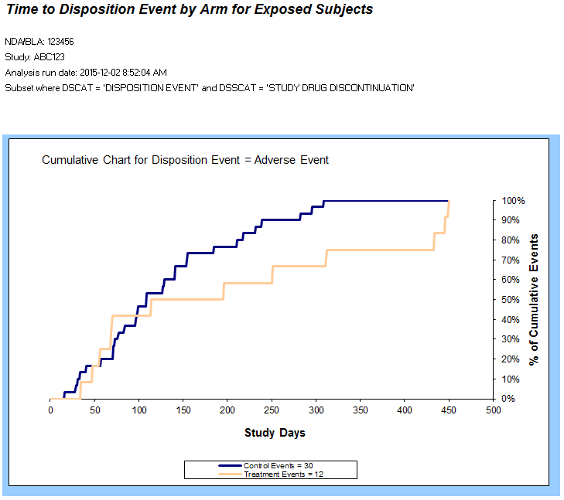
Data Checks: | - Keep track of whether any subjects had no disposition events  - Keep a list of all disposition events that were not used because a study day could not be determined, and keep counts per arm
Assumptions: | The Disposition Analysis Panel assumes:  - The User has access to the following CDISC SDTM dataset: Disposition (DS), Exposure (EX), and Demographic (DM).  - The analysis should not be used with cross-over studies.
Notes and Issues: | Limitations:  - The Disposition Analysis Panel is performed according to the Disposition terms submitted by the sponsor; this means the analysis only displays the Disposition terminologies provided by the sponsor.  - This constrains the automatic processes of the analysis since at the moment there is a lack of terminological consistency across sponsor submissions.  - Since more than 1 disposition event can be used per subject per category and subcategory, this analysis narrows down the observations to just show the last observation for disposition events (note that it is okay for Protocol Milestone to have more than one event listed).  - DS.DSSTDY, DS.DSSTDTC, and DM.RFSTDTC are not at the moment required variables – as a results the sponsor has the option not to submit these variables which Analysis 3 and 4 depend on entirely to produce results.
Approval /  Validation Status: | Status Pending and Validation Required.
Created By: | Juan Cruz Lema-Heyl | Last Updated By: | Peter Glass
Date Created: | 02/26/2010 | Date Last Updated: | 12/8/2015

Appendix
Source Code

/****************************************************************************/
/* PROGRAM NAME: Disposition Analysis Panel */
/* */
/* DESCRIPTION: Find subject counts per arm for each disposition */
/* event appearing in the study, for all subjects */
/* and for exposed subjects */
/* Create charts of the time to disposition event for */
/* all subjects and for exposed subjects */
/* Creates an Excel spreadsheet as output */
/* */
/* EVALUATION TYPE: */
/* */
/* AUTHOR: Andreas Anastassopoulos */
/* (andreas.anastassapoulos@us.ibm.com) */
/* */
/* DATE: December 9, 2009 */
/* */
/* EXTERNAL FILES USED: Disposition_Template.xls -- Excel template */
/* data_checks.sas -- Generic variable checks */
/* data_checks_disposition.sas -- DS data checks */
/* sl_gs_output.sas -- Script Launcher settings output*/
/* err_output.sas -- Error output when missing vars */
/* */
/* PARAMETERS REQUIRED: saspath -- location of external panel SAS programs */
/* utilpath -- location of external util SAS programs */
/* ndabla -- NDA or BLA number */
/* studyid -- study number */
/* */
/* LOCAL ONLY: studypath -- location of the drug study datasets */
/* outpath -- location of the output */
/* outfile -- filename of the output */
/* templatepath -- location of the Excel template */
/* template -- filename of the template */
/* */
/* VARIABLES REQUIRED: DM -- ACTARM or ARM */
/* USUBJID */
/* RFSTDTC if no DSSTDY */
/* DS -- DSDECOD */
/* DSSTDY or DSSTDTC */
/* USUBJID */
/* EX -- USUBJID */
/* */
/* OTHER VARIABLES USED: DM -- ARMCD */
/* IF AVAILABLE DS -- DSCAT */
/* DSSCAT */
/* DSSEQ */
/* */
/* MADE WITH: SAS 9.2 */
/* */
/* NOTES: */
/* */
/****************************************************************************/

/* REVISIONS */
/*
2011-02-17 DK Changed to subject count from event count
Added check for DSSCAT variable
Moved output to separate macro
Updated template to uniform panel style

2011-02-24 DK Moved every section into separate macros
Collapsed time to event code into one macro for both all and exposed
Added checks for all variables

2011-03-05 DK Added grouping & subsetting output
Added handling for missing study day/date variables
Number of DSDECOD terms now stored in separate macro variables for all vs ex

2011-03-27 DK Added run location handling

2011-04-24 DK Fixed an error in determining the number of randomized subjects
when DSCAT and DSSCAT are missing; now determined by looking at DM_DS/DM_DS_EX

2011-05-08 DK Error/no subjects in DM handling

2011-05-10 DK Fixed substr to extract dates, order of sort variables, arm name length,
by_ds2_one datastep where statement to prevent using missing values in a do loop

2011-05-18 DK Changed sort in %ds_by_arm to by dsdy instead of dsstdtc/dsstdy

2011-05-23 DK Added exceptions in the data step that keeps one dsdecod per usubjid/dscat/dsscat
when dsdecod is Informed Consent Obtained or Randomized
Made missing categories/subcategories Missing

2015-06-13 DC Enhanced to filter data and graph by dscat and dsscat
*/

/* the minoperator option allows the use of the in operator by the macro language */
options minoperator;
options missing='';

/* determine the run location by looking for the SL-set run_location macro variable */
%sysfunc(ifc(not %symexist(run_location),%nrstr(%let run_location = local;),));
%put RUN LOCATION: &run_location.;

%macro params;

/* program parameters if the program is run locally */
%if %upcase(&run_location.) = LOCAL %then %do;

data macrovar; set sashelp.vmacro(keep=scope name where=(scope='GLOBAL' & name ne 'RUN_LOCATION')); run;
/* data _null_; set macrovar; call execute('%symdel '||trim(left(name))||';'); run;*/
/* proc datasets kill; quit; */

%global panel_title panel_desc;
%let panel_title = Disposition;
%let panel_desc = ;

/* NDA/BLA number */
/* study number */
/* %global ndabla studyid;*/
/* %let ndabla = 125476;*/
/* %let studyid = C13007;*/

/* %let catc=dscat; */
/* %let subc=dsscat; */
/*
/* %let catdis='DISPOSITION EVENT'; /* Example: 'DISPOSITION EVENT' */ /* All Caps, between quotes */
/* %let subcatdis='END OF TREATMENT'; /* Example: 'END OF TREATMENT' */ /* All Caps, between quotes */

/* location of the study being examined */
/* %let studypath = C:\Users\TAYLORAu\Desktop\BLA 125476\C13007\Data\Disposition;*/

/* libname inlib "&studypath."; */

/* retrieve datasets */
/* data dm; set inlib.dm; run; */
/* data ds; set inlib.ds; run; */
/* data ex; set inlib.ex; run; */

/* location of external SAS programs */
/* %global saspath utilpath;*/
/* %let saspath = C:\Users\TAYLORAu\Desktop\IBM Analysis Panels\SAS Programs\DispositionGeneral;*/
/* %let utilpath = C:\Users\TAYLORAu\Desktop\IBM Analysis Panels\SAS Programs\ZZ_Utilities;*/

/* location and filename of the disposition panel template */
/* %let templatepath = C:\Users\TAYLORAu\Desktop\IBM Analysis Panels\Templates\DispositionGeneral;*/
%let template = Disposition_Template.xls;

/* location and filename of the output */
/* %let outpath = C:\Users\TAYLORAu\Desktop\BLA 125476\C13007\Analysis Panels;*/
%let outfile = Disposition.xls;

%global dispout errout;
%let dispout = &outpath.\&outfile.;
%let errout = &outpath.\Disposition Error Summary.xls;

options noxwait xsync;

/* copy the template to the output file */
x "%str(copy %"&templatepath.\&template.%" %"&dispout.%")";

/* dummy grouping, subsetting, and dataset information datasets */
data sl_datasets;
datatype = ''; name = ''; partition_variable = ''; default = '';
delete;
run;
data sl_group;
group_name = ''; domain = ''; partition = ''; var_name = ''; var_value = ''; dsvg_grp_name = '';
delete;
run;
data sl_subset;
name = ''; domain = ''; partition = ''; var_name = ''; var_value = ''; inner_operator = ''; outer_operator = '';
delete;
run;

%end;

/* program parameters if the program is run through Script Launcher */
%else %do;
%end;

%mend params;

%params;

/* data checks and data check output */
%include "&saspath.\data_checks_disposition.sas";
%include "&utilpath.\data_checks.sas";
%include "&utilpath.\sl_gs_output.sas";
%include "&utilpath.\err_output.sas";

/*****************************************************/
/* PRELIMINARY REQUIRED AND OPTIONAL VARIABLE CHECKS */
/*****************************************************/
%macro ds_prelim_check;

/* check whether there are subjects in DM */
%chk_dm_subj_gt0;

/* required variables */
%chk_var(ds=dm,var=usubjid);
%chk_var(ds=ds,var=dsdecod);
%chk_var(ds=ds,var=usubjid);
%chk_var(ds=ex,var=usubjid);

data rpt_chk_var_req;
set rpt_chk_var;
run;

/* actual arm or planned arm */
%chk_var(ds=dm,var=actarm);
%chk_var(ds=dm,var=arm);

/* insert a row into RPT_CHK_VAR_REQ indicating whether actual arm OR arm exists */
proc sql noprint;
insert into rpt_chk_var_req
set chk = 'VAR',
ds = 'DM',
var = 'ACTARM or ARM',
condition = 'EXISTS',
ind = %sysfunc(ifc(&dm_actarm. or &dm_arm.,1,0));
quit;

/* study day of disposition event OR (start date of disposition event AND subject reference start date) */
%chk_var(ds=ds,var=dsstdtc);
%chk_var(ds=ds,var=dsstdy);
%chk_var(ds=dm,var=rfstdtc);

proc sql noprint;
insert into rpt_chk_var_req
set chk = 'VAR',
ds = 'DM/DS',
var = 'DSSTDY or (DSSTDTC and RFSTDTC)',
condition = 'EXISTS',
ind = %sysfunc(ifc(&ds_dsstdy. or (&ds_dsstdtc. and &dm_rfstdtc.),1,0));
quit;

/* set a flag indicating whether all required variables are present */
%global all_req_var;
proc sql noprint;
select (case when count = 0 then 1 else 0 end) into: all_req_var
from (select count(1) as count
from rpt_chk_var_req
where ind ne 1);
quit;

/* optional variables */
%chk_var(ds=dm,var=armcd);
%chk_var(ds=ds,var=dscat);
%chk_var(ds=ds,var=dsscat);
%chk_var(ds=ds,var=dsseq);

/* if study day exists or date variables exist to compute study day, time to event can be done */
%global ds_tte;
%if &ds_dsstdy. or (&dm_rfstdtc. and &ds_dsstdtc.) %then %let ds_tte = 1;
%else %let ds_tte = 0;

%mend ds_prelim_check;

/**********************************************/
/* DISPOSITION ANALYSIS DATASET PREPROCESSING */
/**********************************************/
%macro ds_setup;

%put **********************************************;
%put * DISPOSITION ANALYSIS DATASET PREPROCESSING *;
%put **********************************************;

/* used ACTARM if it is available */
%if &dm_actarm. %then %do;
proc datasets library=work;
modify dm;
rename %if &dm_arm. %then arm=plannedarm;
actarm=arm;
quit;
%end;

data dm;
set dm;

%if &dm_armcd. %then %do;
if upcase(ARMCD) in("SCRNFAIL","NOTASSGN") then delete;
%end;

/* put arm into propcase */
arm_display = arm;
if arm_display ne '' and not anylower(arm_display) then do;
length arm_word $50;
i = 1;
arm_word = scan(arm_display,i);
do while (arm_word ne '');
if length(arm_word) > 3 and not anydigit(compress(arm_word))
then substr(arm_display,index(arm_display,compress(arm_word)),length(compress(arm_word))) = propcase(compress(arm_word));
if compress(arm_word) in ('MG' 'KG')
then substr(arm_display,index(arm_display,compress(arm_word)),length(compress(arm_word))) = lowcase(arm_word);
if compress(arm_word) = ('ML')
then substr(arm_display,index(arm_display,compress(arm_word)),length(compress(arm_word))) = 'mL';
i = i + 1;
arm_word = scan(arm_display,i);
end;
end;
arm = arm_display;
drop arm_display arm_word i;
run;

data ds ;
set ds;
if not anylower(dsdecod) then dsdecod = propcase(dsdecod);

%if &ds_dscat. %then %do;
if missing(dscat) then dscat = 'Missing';
if not anylower(dscat) then dscat = propcase(dscat);
%end;
%else %do;
dscat = 'Missing';
%end;

%if &ds_dsscat. %then %do;
if missing(dsscat) then dsscat = 'Missing';
if not anylower(dsscat) then dsscat = propcase(dsscat);
%end;
%else %do;
dsscat = 'Missing';
%end;
run;

*data ex;
* set ex;
*run;

* Obtain demographics and people for each of the disposition terms;
proc sort data = dm;
by usubjid;
run;

proc sort data = ds;
by usubjid;
run;

proc sort data = ex nodupkey;
by usubjid;
run;

data dm_ds;
merge dm (in=b) ds (in=a);
by usubjid;
if a and b;
run;

data dm_ds;
set dm_ds;

%if &ds_dsstdy. %then %do;
dsdy = dsstdy;
%end;

%else %if &dm_rfstdtc. and &ds_dsstdtc. %then %do;
dss_year = substr(left(dsstdtc),1,4);
dss_month = substr(left(dsstdtc),6,2);
dss_day = substr(left(dsstdtc),9,2);
dss_date = mdy( dss_month, dss_day, dss_year);

rfs_year = substr(left(rfstdtc),1,4);
rfs_month = substr(left(rfstdtc),6,2);
rfs_day = substr(left(rfstdtc),9,2);
rfs_date = mdy( rfs_month, rfs_day, rfs_year);

if dss_date >= rfs_date then do;
dsdy = (dss_date - rfs_date + 1);
end;
else do;
dsdy = (dss_date - rfs_date);
end;
%end;

%else %do;
length dsdy 8. dsstdy 8. rfstdtc $1 dsstdtc $1;
call missing(dsdy,dsstdy,rfstdtc,dsstdtc);
%end;
run;

** MERGE ON THE EX FILE TO SUBSET **;

data dm_ds_ex;
merge dm_ds(in=d) ex(in=e keep=usubjid);
by usubjid;
if d and e;
run;

%mend ds_setup;

/**********************/
/* DISPOSITION BY ARM */
/**********************/
%macro ds_by_arm(infile,outfile);

%put ******************************************;
%put * DISPOSITION EVENTS BY ARM for &infile. *;
%put ******************************************;

** Revised logic part of the program starts here ****;
**IF THE VARIABLES ARE MISSING THEY WILL BE SET TO MISSING ***;

proc sort data=&infile. out=&infile._sort;
by usubjid dscat dsscat %if &ds_dsstdtc. %then dsstdtc; %else %if &ds_dsstdy. %then dsstdy;;
run;

/* keep only the last disposition event per category and subcategory */
/* keep death if there are multiple disposition events on a single day */
data &infile._sort;
set &infile._sort;
if upcase(dsdecod) = 'DEATH' then order = 100;
else order = 1;
run;

proc sort data=&infile._sort out=&infile._sort;
by usubjid
dscat
dsscat
dsdy
order
%if &ds_dsseq. %then dsseq;
dsdecod;
run;

/* pick out the last disposition event per subject in each category and subcategory */
/* category/subcategory/subject level */
data &infile._cscsl;
set &infile._sort;
by usubjid dscat dsscat;

if upcase(dscat) ne 'PROTOCOL MILESTONE'
and not (upcase(dsdecod) =: 'INFORMED CONSENT OBTAINED')
and not (upcase(dsdecod) =: 'RANDOMIZED')
then do;
if last.dsscat;
end;
run;

proc sql noprint;
create table by_cat as
select dscat, dsscat, dsdecod, arm, count(distinct usubjid) as num_by_cat
from &infile._cscsl
group by dscat, dsscat, dsdecod, arm;
quit;

/*proc summary data = dm_ds_a nway;
class dscat dsscat dsdecod arm;
output out = by_cat(drop=_type_ rename=(_freq_=num_by_cat));
run;*/

* Create the denominator total out of the randomized ;
* Total Randomized Patients ;

* Total Randomized Patients by Treatment ;
proc sql noprint;
create table ran_arm as
select arm, count(distinct usubjid) as total_count
from &infile.
where upcase(dsdecod) like 'RANDOM%'
group by arm;
quit;

data ran_arm;
set ran_arm;
arm_n + 1;
run;

** CHECK TO SEE IF THERE ARE ANY RANDOMIZED, IF NOT CALCULATE ARM N **;
%global num_random;
proc sql noprint;
select count(*) into: num_random
from ran_arm;
quit;

%if &num_random. = 0 %then %do;

proc sql noprint;
create table ran_arm as
select arm, count(distinct usubjid) as total_count
from dm_ds
group by arm;
quit;

data ran_arm;
set ran_arm;
arm_n + 1;
run;

proc sql noprint;
select count(1) into: num_random
from ran_arm;
quit;

%end;

** COMBINE BREAKDOWN WITH NUMBER BY ARM ***;

proc sql;
create table by_cat_arm
as select b.*, r.*
from by_cat b, ran_arm r
where b.arm = r.arm
order by dscat, dsscat, dsdecod, arm
;
quit;

** NOW MAKE ONE OBS FOR EACH STANDARD TERM ***;

data by_dsdecode (drop=total_count num_by_cat arm I arm_n);
set by_cat_arm;
by dscat dsscat dsdecod;
retain n_arm1 - n_arm%eval(&num_random.) n1 - n%eval(&num_random.) p_arm1 - p_arm%eval(&num_random.) name1 - name%eval(&num_random.);
format name1 - name%eval(&num_random.) $100.;
array ns{*} n_arm1 - n_arm%eval(&num_random.);
array nds{*} n1 - n%eval(&num_random.);
array percs{*} p_arm1 - p_arm%eval(&num_random.);
array names{*} $ name1 - name%eval(&num_random.);

ns{arm_n} = total_count;
nds{arm_n} = num_by_cat;
percs{arm_n} = 100*num_by_cat/total_count;
names{arm_n} = arm;

dscat = propcase(dscat);
dsdecod = propcase(dsdecod);
if index(dscat,'Mile') then sorter = 1;
else sorter = 2;

if last.dsdecod then do;
tot_perc = sum(of p_arm:);
output;
do I = 1 to &num_random.;
nds{I} = 0;
percs{I} = 0;
end;
end;
run;

proc sort data = by_dsdecode;
by sorter dscat dsscat decending tot_perc;
run;

data by_dsdecode;
set by_dsdecode;
by sorter dscat dsscat;
if not first.dscat then dscat = '';
if not first.dsscat then dsscat = '';
run;

** NOW I NEED TO GET THE VARIABLES INTO THE CORRECT ORDER FOR EXPORTING ***;

%macro order;

%do I = 1 %to &num_random.;

data order&I;
format order $8.;
order = "n_arm&I.";
output;
order = "n&I.";
output;
order = "p_arm&I.";
output;
order = "name&I.";
output;
run;

%end;

%mend order;

%order;

data order;
set order:;
run;

proc sql noprint;
select order into: order separated by ','
from order;
quit;

proc sql;
create table &OUTFILE.
as select dscat, dsscat, dsdecod, &order
from by_dsdecode
;
quit;

PROC STDIZE DATA=&OUTFILE. REPONLY MISSING=0 OUT=&OUTFILE.;
VAR _numeric_;
RUN;

/* clean up */
proc datasets library = work;
delete order:;
run;
quit;

%mend ds_by_arm;

/************************************/
/* TIME TO DISPOSITION EVENT BY ARM */
/************************************/
%macro time_to_event(ds);

%put **************************************;
%put * TIME TO DISPOSITION EVENT for &ds. *;
%put **************************************;

/* disposition event study day or date variables to calculate it must be available */
%if &ds_tte. %then %do;

/* set the time-to-event failure note to empty */
%if not %symexist(tte_fail_note) %then %do;
%global tte_fail_note;
%let tte_fail_note = ;
%end;

** THE FOLLOWING CREATES THE LITTLE GRAPHS ***;

** DEDUPE DATA **;
proc sort data = &ds. nodupkey dupout = &ds._dupes;
by usubjid dsdecod dsdy;
run;

/*Start of 6/13 enhancement*/

%if &subcatdis~= %then %do;

** NUMBER OF EACH BY ARM DSDECOD ***;

proc summary data = &ds. nway;
class arm dsdecod;
where upcase(&subc.)=&subcatdis and upcase(&catc.)=&catdis;
output out = by_dsdecod(drop=_type_ rename=(_freq_=tot_dsdecod));
run;

** NUMBER OF EACH BY ARM BY DAY ***;

proc summary data = &ds. nway;
class arm dsdecod dsdy;
where upcase(&subc.)=&subcatdis and upcase(&catc.)=&catdis;
output out = by_dsdecod_day(drop=_type_ rename=(_freq_=by_dsdecod));
run;

%end;

%if &subcatdis= and &catdis~= %then %do;

** NUMBER OF EACH BY ARM DSDECOD ***;

proc summary data = &ds. nway;
class arm dsdecod;
where upcase(&catc.)=&catdis;
output out = by_dsdecod(drop=_type_ rename=(_freq_=tot_dsdecod));
run;

** NUMBER OF EACH BY ARM BY DAY ***;

proc summary data = &ds. nway;
class arm dsdecod dsdy;
where upcase(&catc.)=&catdis;
output out = by_dsdecod_day(drop=_type_ rename=(_freq_=by_dsdecod));
run;

%end;

%if &subcatdis= and &catdis= %then %do;

** NUMBER OF EACH BY ARM DSDECOD ***;

proc summary data = &ds. nway;
class arm dsdecod;
output out = by_dsdecod(drop=_type_ rename=(_freq_=tot_dsdecod));
run;

** NUMBER OF EACH BY ARM BY DAY ***;

proc summary data = &ds. nway;
class arm dsdecod dsdy;
output out = by_dsdecod_day(drop=_type_ rename=(_freq_=by_dsdecod));
run;

%end;

/*End of 6/13 Enhancement*/

** NOW GET THE MAX DAY IN THE STUDY ***;

proc sql noprint;
select max(dsdy) into: max_day
from by_dsdecod_day;
quit;

** NOW RUN THROUGH AND DO THE CUMMULATIVE NUMBER OF EACH EVENT AND ALL THE NUMBER OF DAYS ***;

data by_dsdecod_day1 (keep = arm dsdecod dsdy1 cum_dsdecod);
set by_dsdecod_day;
by arm dsdecod;
retain cum_dsdecod;

dsdy0 = lag(dsdy);
if first.dsdecod then do;
if dsdy < 0 then do;
dsdy1 = dsdy;
cum_dsdecod = by_dsdecod;
output;
end;
else do;
do J = 0 to dsdy;
dsdy1 = J;
if dsdy1 = dsdy then cum_dsdecod = by_dsdecod;
else cum_dsdecod = 0;
output;
end;
end;
end;
else do;
days_between = abs(dsdy0-dsdy);
if days_between = 1 then do;
dsdy1 = dsdy;
cum_dsdecod = cum_dsdecod+by_dsdecod;
output;
end;
else do;
do I = 1 to days_between;
dsdy1 = dsdy0+I;
if dsdy1 = dsdy then cum_dsdecod = cum_dsdecod+by_dsdecod;
output;
end;
end;
end;
run;

** MERGE TOTAL ON TOGETHER AND CALCULATE CUMMULATIVE PERCENT ***;

data by_ds;
merge by_dsdecod_day1 by_dsdecod ;
by arm dsdecod;

cum_percent = cum_dsdecod/tot_dsdecod;
run;

** NOW FIGURE OUT THE NUMBER OF ARMS AND THE NUMBER OF DSDECODS AND NUMBER OF DAYS FOR DSDECOD **;

proc sql;
create table arm
as select distinct arm
from by_dsdecod
;
quit;

** THIS GETS A NUMERIC FOR EACH ARM ***;
data arm;
set arm;
n_arm = _n_;
run;

%global num_arms;
proc sql noprint;
select count(*) into: num_arms
from arm;
quit;

** NOW I FIGURE OUT HOW MANY EACH DSDECOD OCCURED TO GET UP TO 12 INTERESTING ONES ***;
** THIS PUTS THEM IN ORDER ***;
proc sql;
create table dsd_num
as select dsdecod, sum(tot_dsdecod) as num_events
from by_dsdecod
group by dsdecod
order by num_events descending;
quit;

/* determine the macro variable to use for the number of DSDECOD terms */
%if not %sysfunc(index(&ds.,ex)) %then %let rlimit = num_dsd;
%else %let rlimit = num_dsde;

data dsd_num (keep = dsdecod order);
set dsd_num end=eof;
order = _n_;
twelve = 12;
if eof then do;
call symputx("&rlimit.",put(min(_n_,12),8. -l),'g');
end;
run;

** NOW I NEED TO GET ALL THE ARMS LINED UP CORRECTLY for EACH DSDECOD**;

** MERGE FILES TOGETHER **;

proc sql;
create table by_ds2
as select b.*, a.*, d.*
from by_ds b, arm a, dsd_num d
where b.dsdecod = d.dsdecod and
b.arm = a.arm
order by d.order, b.dsdy1
;
quit;

data by_ds2_one(keep = dsdecod order dsdy1 c_perc1-c_perc%eval(&num_arms.));
set by_ds2 end=eof;
by order dsdy1;
retain c_perc1-c_perc%eval(&num_arms.);
array c_percs{*} c_perc1-c_perc%eval(&num_arms.);

where dsdy1 ne .;

if first.order then do;
do I = 1 to %eval(&num_arms.);
c_percs{I} = 0;
end;
end;

c_percs{n_arm} = cum_percent;
if last.dsdy1 then output;

if last.order then do;
if dsdy1 < &max_day. then do;
do J = dsdy1+1 to %eval(&max_day.);
dsdy1 = J;
output;
end;
end;
end;
run;

** GET UNIQUE ARM DSDECODE OBS TO BE USED IN LABELS ***;

proc sort data = by_ds2 out = for_labels(keep = order dsdecod tot_dsdecod n_arm) nodupkey;
by order n_arm;
run;

* Break up the file by DSDECOD Term and Export ;
** I WANT TO CREATE A LABEL FOR EACH THAT HAS THE NUMBER OF OBS IN IT ***;
%global lable1 lable2 lable3 lable4 lable5 lable6 lable7 lable8;

%do a=1 %to &&&rlimit.;

** THIS WILL HAVE THE NUMBER OF OBS FOR EACH ARM IN THE DSDECOD WE ARE WORKING ON ***;

data for_labels1(keep=tot_dsdecod n_arm);
set for_labels;
if order = &a.;
run;

** CREATE A LABEL FOR THE DSDECOD **;
data _null_;
set for_labels;
format dsdtext $100.;
if order = &a.;
dsdtext = "Cumulative Chart for Disposition Event = "||trim(compress(dsdecod,';'));
call symput('dsd_label',dsdtext);
run;

** THIS WILL HAVE THE LABEL TEXT FOR EACH ***;
data for_labels1;
format text $200.;
merge for_labels1 arm;
by n_arm;
if tot_dsdecod = . then tot_dsdecod =0;
text = "label c_perc"||compress(_N_)||' = "'||trim(compress(arm,,'c'))||' Events = '||compress(tot_dsdecod)||'"';
run;

** CREATE A MACRO FOR EACH ***;

%do L = 1 %to &num_arms.;

data _null_;
set for_labels1;
if _N_ = &L;
call symput("lable&L.",trim(text));
run;

%end;

** NOW SUBSET THE DATA AND USE THE LABELS ***;

data dsdecod&a.%sysfunc(ifc(%sysfunc(index(&ds.,ex)),e,)) (drop = order);
length dsdecod $ 200;
set by_ds2_one;
if order = &a.;

dsdecod = "&dsd_label.";

%do L2 = 1 %to &num_arms.;
&&lable&L2.;
%end;
run;

%end;

%end;
%else %do;

%put;
%put WARNING: Study day or date variables not available;
%put;

%if not %symexist(tte_fail_note) %then %do;
%global tte_fail_note;
%let tte_fail_note = Time to event analysis could not be performed because
study day and date variables used to compute study day were not available;
%let tte_fail_note = %sysfunc(compbl(&tte_fail_note.));
%end;

%end;

%mend time_to_event;

/***********************/
/* CREATE EXCEL OUTPUT */
/***********************/
%macro ds_out;

%put ********************************************;
%put * CREATE DISPOSITION ANALYSIS EXCEL OUTPUT *;
%put ********************************************;

** ADD IN THE DATA INFORMATION ***;
data lib;
length path $500;
path = "&ndabla.";
output;
path = "&studyid.";
output;
path = compbl(put(date(),e8601da.)||' '||put(time(),timeampm11.));
output;
path = "&sl_custom_ds.";
output;
path = "&tte_fail_note.";
output;
path = ifc(&dm_actarm.,'actual treatment arm (ACTARM)','planned treatment arm (ARM)');
output;
%if &subcatdis~= %then %do;
path = "Subset where &catc. = &catdis. and &subc. = &subcatdis.";
output;
%end;
%if &subcatdis= %then %do;
path = "Subset where &catc. = &catdis.";
output;
%end;
run;

%if not %symexist(run_location) %then %let run_location = LOCAL;

/* local runs use the Microsoft Jet database-based Excel LIBNAME engine */
%if %upcase(&run_location.) = LOCAL %then %do;
*libname xls excel "&dispout." ver=2003; *Output function changed due to SAS 9.3(64bit) and Excel 2010(32bit) incompatability;
libname xls pcfiles path="&dispout.";
%end;
/* Script Launcher runs use the PCFILES LIBNAME Engine */
%else %do;
libname xls pcfiles path="&dispout.";
%end;

proc sql noprint;
drop table xls.DispositionANew,
xls.DispositionBNew,
%if &ds_tte. %then %do;
%do a = 1 %to &num_dsd.;
xls.Sheet&a.,
xls.Sheet&a.E,
%end;
%end;
xls.Info
;
quit;

data xls.DispositionANew;
set final_dispositionA;
run;

data xls.DispositionBNew;
set final_dispositionB ;
run;

%if &ds_tte. %then %do;

%do a = 1 %to &num_dsd.;

data xls.Sheet&a.(dblabel=yes);
set dsdecod&a.;
run;

%end;

%do a = 1 %to &num_dsde.;

data xls.Sheet&a.E(dblabel=yes);
set dsdecod&a.e;
run;

%end;

%end;

data xls.Info;
set lib;
run;

libname xls clear;

%mend ds_out;

/**********************************/
/* RUN DISPOSITION ANALYSIS PANEL */
/**********************************/
%macro ds;

%ds_prelim_check;

%if &dm_subj_gt0. and &all_req_var. %then %do;

%ds_setup;

%ds_by_arm(dm_ds,final_dispositionA);

%ds_by_arm(dm_ds_ex,final_dispositionB);

%time_to_event(dm_ds);

%time_to_event(dm_ds_ex);

/* do preprocessing of Script Launcher datasets */
%group_subset_pp;

%ds_out;

/* data checks */
%disposition_check;

%disposition_check_out;

/* create grouping & subsetting output */
%group_subset_xls_out(gs_file=&dispout.);

%end;
%else %do;
%error_summary(err_file=&errout.,
err_nosubj=%sysfunc(ifc(&dm_subj_gt0.,0,1)),
err_missvar=%sysfunc(ifc(&all_req_var.,0,1))
);
%end;

%mend ds;

/* run the disposition panel */
%ds;

